[Enter program notes, texts, bios, etc. here]

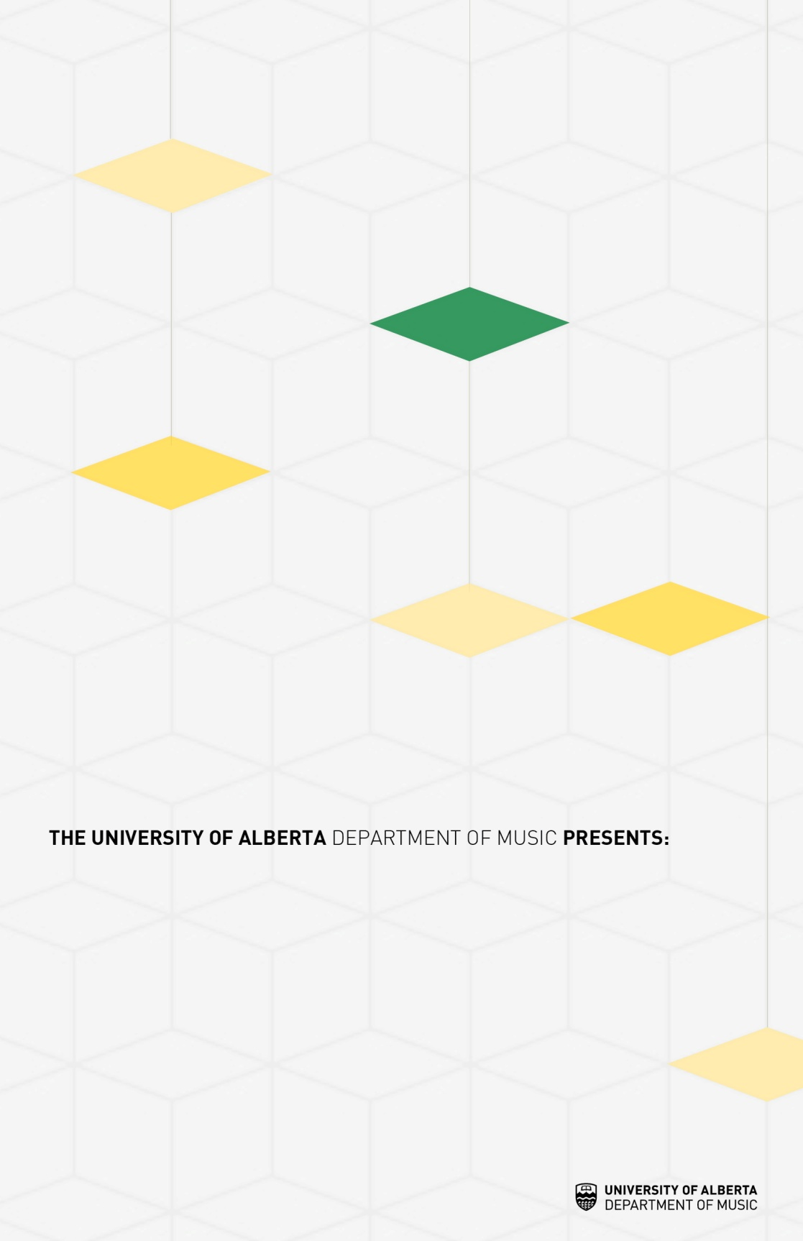

[Concert date, location and time go here]

[Main musicians/details go here]

[Concert Title Goes Here]

[Enter program notes, texts, bios, etc. here]

[Enter program notes, texts, bios, etc. here]