[Enter program notes, texts, bios, etc. here]

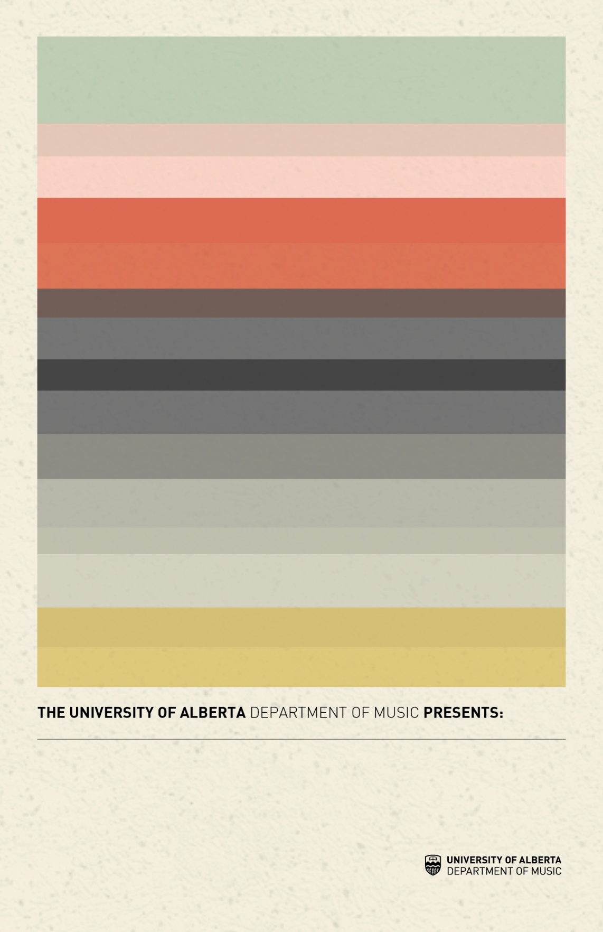

**[Concert Title Goes Here]**

**[Concert date, location and time go here]**

[Insert main musicians, or other important event details here]

[Enter program notes, texts, bios, etc. here]

[Enter program notes, texts, bios, etc. here]