SoTL Scholars Program

At the University of Alberta, we aspire to “excel as individuals, and together, sustain a culture that fosters and champions distinction and distinctiveness in teaching, learning, research, and service” (For the Public Good, 2016, p. 17), to “inspire, model, and support excellence in teaching and learning” (p. 21). For this purpose we have promised to “foster, encourage, and support innovation and experimentation in curriculum development, teaching, and learning” (p. 17), and to “ensure that learning experiences at our university are of the highest quality, based on a practice of continuous improvement and innovation in teaching” (p. 17).

The Scholarship of Teaching and Learning (SoTL) seeks to understand or improve student learning and the teaching approaches and practices that affect student learning. Research on teaching, or SoTL, is a scholarly activity in which an instructor engages in careful planning, evaluation, and dissemination of their study in order to inform their own teaching and also to influence practice beyond their own classroom. It is practiced across all disciplines in higher education and thus employs a wide range of lenses and methods (Miller-Young & Yeo, 2015, p. 39). SoTL researchers seek to understand their students’ learning better and what they are experiencing in their learning by exploring the effectiveness and desirability of what they do in and through higher education.

The SoTL Scholars Program seeks to support instructors who wish to systematically study their teaching strategies to develop SoTL capacity at the University, positively impact students’ learning, stimulate discussions about what works in teaching and learning, and improve the teaching and learning environment.

The SoTL Scholars Program will provide opportunities for new as well as experienced instructors to receive tailored support to 1) try innovative teaching strategies, 2) systematically evaluate them, and 3) disseminate the results in a scholarly venue. Applications are invited from all academic faculty members and academic teaching staff.

The SoTL Scholars Program entails
- Individual consultations: working with a CTL Educational Developer to effectively design or refine the teaching strategy and/or working with the CTL Research Coordinator to develop research questions and methods.
- Collaboration meetings: scholars will meet approximately every three weeks with a multidisciplinary cohort of other SoTL program participants, facilitated by CTL.
- Developing research questions, approaches, and dissemination

Participants will:
  - Have access to a team of graduate research assistants (GRAs) who assist with the literature review, ethics application, data collection, and analysis; GRA team facilitated by CTL.
  - Present findings within the cohort and at an institutional venue (e.g. department meeting, co-present a CTL workshop, Festival of Teaching and Learning).
  - Complete projects that commit to present at the Festival of Teaching and Learning will have access to a TLEF Professional Teaching Development grant for presenting at a scholarly conference.

Selection Criteria
Projects will be evaluated on the merit of their research topic, clarity of the research question, and availability. A completed PDF of this application form should be submitted to the Strategic Initiatives Manager, Centre for Teaching and Learning, c/o awards.ctl@ualberta.ca. Questions about the program can be directed to Associate Director Neil Haave through CTL's request a consultation form.

Expected Timeline
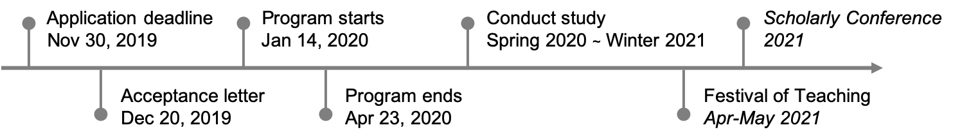
Application Details

Applicant’s Name: | Department or Division and Faculty or School:
Applicant’s Position and Date of Appointment: | U of A Mailing Address:
Phone Number: | Email:
Discipline / Course(s)
Please list those course(s) for which you have been appointed or are involved in a teaching or design capacity:
(provide course number and titles).

Research Topic / Question
Please provide a possible question about your teaching or your students’ learning you are interested in investigating.

Availability
Collaboration meetings will occur on Tuesdays or Thursdays starting January 14, 2020 and will run approximately every three weeks until April 23. Please indicate your availability by appending a copy of your Winter 2020 timetable.
Teaching Philosophy
Briefly, please write a few paragraphs on the next two pages (maximum two) explaining your teaching philosophy and how this philosophy is applied to the classroom strategies you use to facilitate students’ learning.
Signature of Applicant:

_______________________________________________
Signature Date

