eForm – Teachers Honorarium
This Quick Reference Guide provides basic information relating to the submission of an eForm for payment of a Teachers Honorarium. This guide is not a comprehensive reference of all scenarios you may see. If you have questions or need further information, please contact your Department HR Contact.

Overview
The payments will be provided to Payroll on a spreadsheet from the Faculty of Education. To process the payment using eForms follow the steps below:
- Personal Info – Verify the personal information against the spreadsheet
- Home Address and Phone Numbers – The home address must be the school address as indicated on the spreadsheet
Navigation
PeopleSoft HCM > Main Menu > UofA eForms WorkCenter > Add an eForm > Search Active Employee
eForm - Data Entry
Form Section | Data Element | Data Requirement
Search Fields | - Last Name, First Name | - Ensure use of upper and lower case
Person ID Search | - Person ID | - If a name is returned in the search – ensure name matches the name on the spreadsheet  - If names do not match submit an Name Change form – See QRG eForm-Changing an Employee’s Personal Information
Home Address & Phone Number | - Address 1 | - Name of School
 | - Address 2 | - Street Address
 | - City/Prov/Postal Code | - Ensure address is entered as indicated on the spreadsheet
 | - Business Phone | - Optional
Basic Job Info | - Effective Date | - Enter the start of the current month that is being processed
 | - Employment Type | - Person of Interest
 | - Employment Type | - Paid
 | - Employee Group | - 267 Teacher’s Honorarium One Time Payment
Job Info | - Job Code | - V0013 – Teachers Honorarium
 | - Department | - Verify from spreadsheet – usually 183000
 | - Standard Hours | - Leave default of 1.00
 | - FTE | - Leave default of 1.00
 | - Appointment End Date | - End of the current month
One Time Pay | - Hire with One Time Pay | - Click the box
 | - Earnings Code | - 551 – Teacher Honorm (T4A)
 | - Pay Period Begin Date | - Enter first day of the month which is being processed
 | - Pay Period End Date | - Enter the last day of the month which is being processed
 | - Amount | - Enter amount to be paid – Verify with spreadsheet
 | - Select Combo Code | - Enter Combo Code
Banking Information | - Direct Deposit Account Type  - Bank ID  - Bank Branch ID  - Account Number | - Enter information from spreadsheet
Action/Reason | - Action = POI  - Reason = NEW | - Will default in
Action Items | - SIN Verification | - Click the box - Verify with spreadsheet
Comments | - Click arrow | - Enter any information an approver may require to approve

Helpful Hints
- Know your Approval Cut-off Times. Check with your Department HR Contact to confirm.

Screen shots

Home Address and Phone Numbers
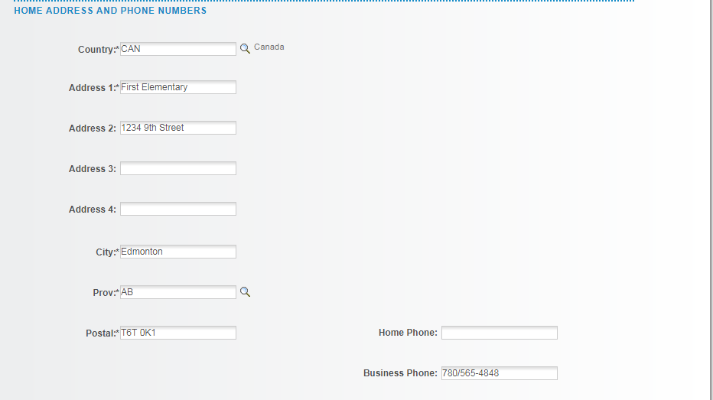

Basic Job Info
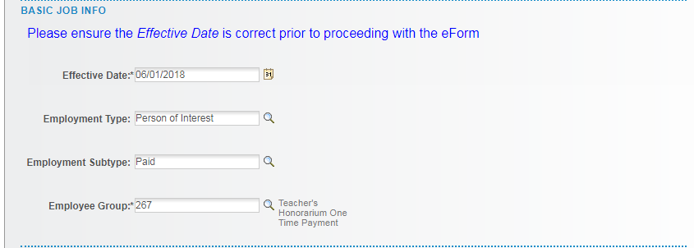

Job Info
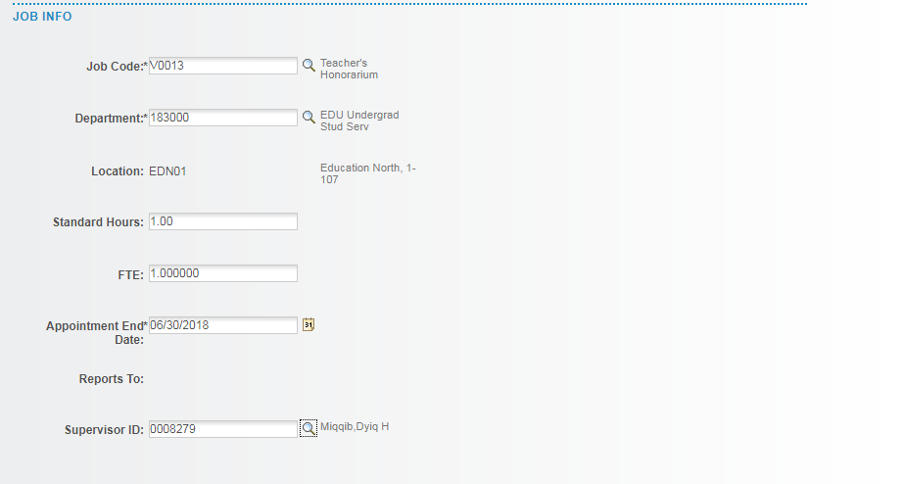

One Time Pay

One Time Pay
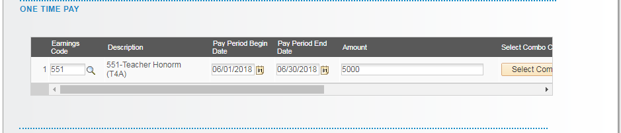

Banking Information

Action/Reason

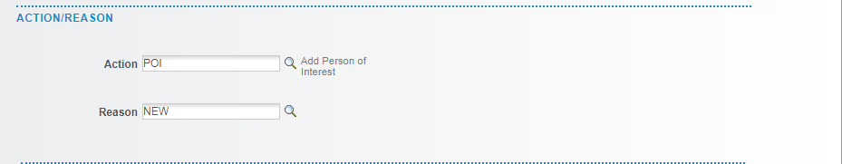

SIN Verification

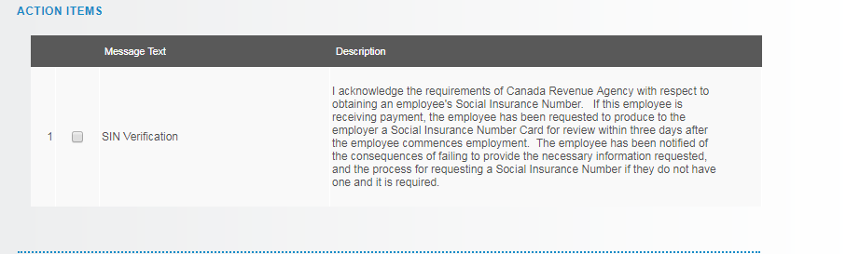

Comments

