eForm – Merit Increment (Not on Reappointment) for *TRAS, *TAPS, and *ATS
This Quick Reference Guide provides basic information relating to the submission of an eForm for a Temporary Academic Employee increment submission. This guide is not a comprehensive reference of all scenarios you may see. If you have questions or need further information, please contact your Department HR Contact.

This process is to be used to award an increment during the term of mid-appointment
Navigation
PeopleSoft HCM > Main Menu > UofA eForms WorkCenter > Add an eForm > Search Active Employee
Attachments
Before you start an eForm submission, ensure you have the following information scanned and ready to attach to the eForm:
- Original signed letter of notification for increment increase (This may be optional)
Other Information Required
- Employee must have a current appointment with an end date into the future
eForm - Data Entry
Form Section | Data Requirement
Search Fields | - Search for Active Temporary Academic Employee
Select Current Active Job | - Appointment must have a future end date past the increment date
Action Selection | - Select Take Other Job Action
Basic Job Info | - Enter effective date
Job Info | - Ensure Appointment end date is beyond the increment date
Attachment | - If a letter was sent to the employee confirming the increment – attach this document
Compensation Information | - Change compensation as per increment calculation
Action/Reason | - Action – Pay Rate Change (PAY)  - Reason – Merit (MER)
Comments | - Comments must include # of Increments given and calculation of the new salary  - Include total value of increments  - If 0.00 is given – a reason must be indicated for the zero value

The backup documentation and the information on the eForm must match. If they do not match, enter comments in the Comment section to explain the reasons why. This will help HRS when vetting the form.

Example:
Employee with a 2-year appointment, July 1, 2017 to June 30, 2019 is eligible for an increment July 1, 2018. You can process this increment through the eForm rather than a paper PAF.

Screen Shots – Example

Search for active Temporary Academic employee

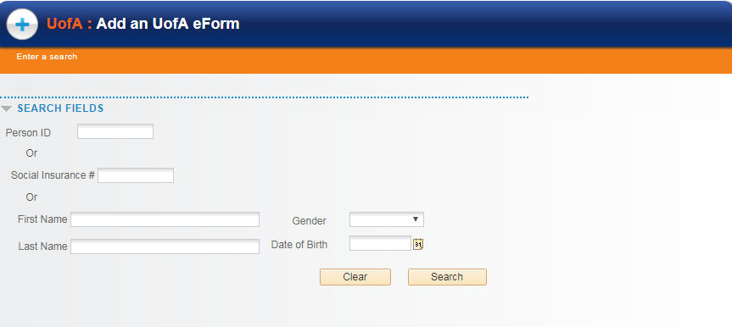

Select active Temporary Academic employee

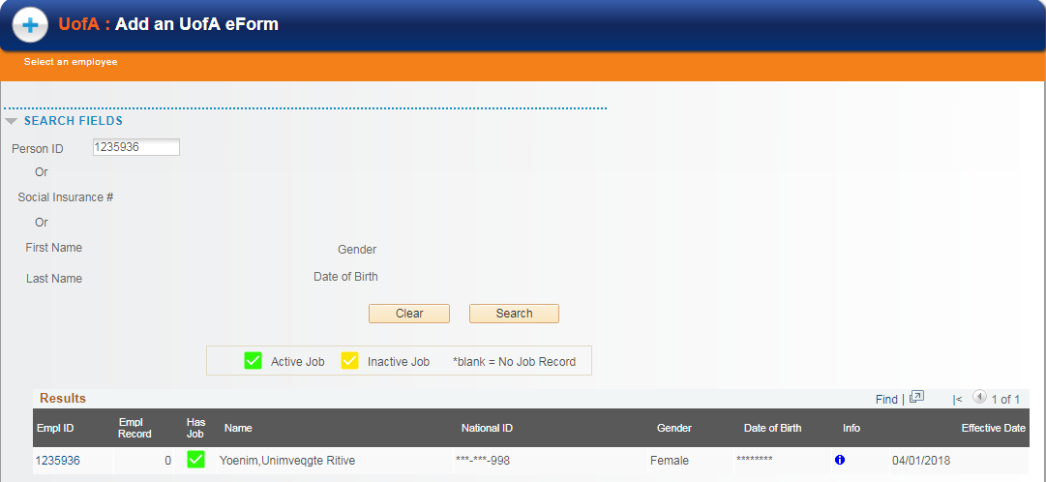

Compensation rate will change

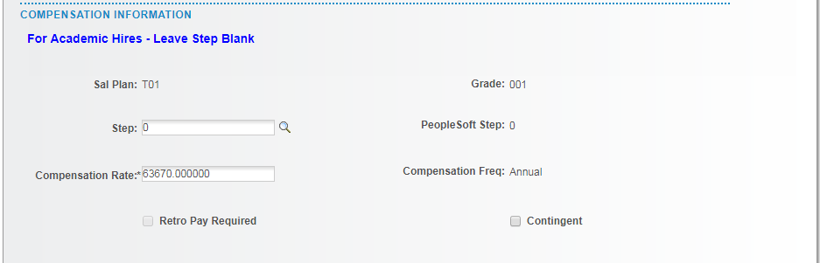

Change Action and Reason Code to:

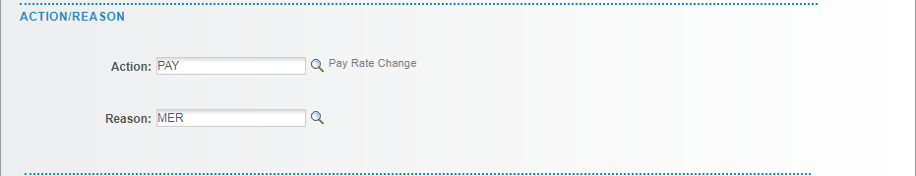

Example of Comment requirement

