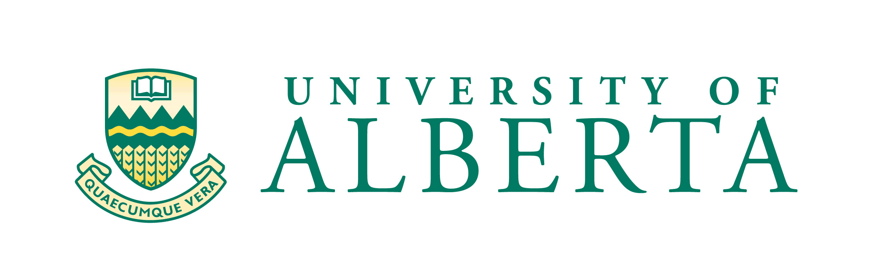
Department of Obstetrics and Gynecology
5S131 Lois Hole Hospital for Women, Robbins Pavilion, obgyn.ualberta.ca
Royal Alexandra Hospital Fax: 780.735.4981
10240 Kingsway Avenue
Edmonton, Alberta, Canada T5H 3V9

WCHRI and Department of Obstetrics & Gynecology
Resident/Clinical Fellow Trainee Research Grant
Instructions on Application Process
Applications may be submitted at any time to:
Jeannine Flores Bastidas, Research Administrator
Department of Obstetrics & Gynecology Administrative Office
5S 116-1 Lois Hole Hospital for Women, Robbins Pavilion

Resident/Clinical Fellow Trainee Research Grants may be held by Department of Obstetrics & Gynecology trainees currently engaged in the following recognized full-time University of Alberta training programs and whose research is focused on women and children's health:
- Residency,
- Subspecialty Residency, and
- Clinical Fellowship.

The Resident Research opportunity offers awardees the resources and support to carry out an independent research project during their residency. The proposed work should be within the applicant’s ability to execute independently, within the time available, with the support of the proposed mentor. This opportunity is often the applicant’s first foray into research. Awardees may hold this grant once per eligible program.

Applicants must be a WCHRI trainee member and be supervised by a WCHRI academic member who is a University of Alberta faculty member. All applicants are expected to work with their mentor to develop the application particularly with respect to the research proposal. Additionally, mentors are expected to provide advice and support to ensure satisfactory project completion and timely research outcomes.

The applicant and mentor should ensure that the hypothesis/research question, objectives, methodological approach and expected outcomes are described in sufficient detail for the reviewers to be able to assess the feasibility and overall merit of the proposed research in terms of its suitability as a training opportunity. The role of the candidate, mentor and if applicable, co-investigators must be clearly evident. The applicant is responsible for ensuring that the application is complete. In keeping with the mentoring and training aspects of the award, applicants may be solicited to provide additional information or amendments. Applicants may only request research funds that apply to specific aspects of the research that have not started before the commencement of award funding.

Instructions for Completion of Application Form
- Read the guidelines and application before you start filling out the application form.
- Do not exceed the space provided. Additional pages may be provided only where indicated.
- Do not submit photo-reduced, double-sided or stapled application material.
- The complete, original, signed application must be received by department administration with:
  - Signatures as per the first page of the application form;
  - Supporting documents as required (i.e. original, signed letter of support for off-site research, budget justification, quotes/proof of pricing, applicant and mentor(s) CVs;
  - If you are requesting statistical support, you MUST attach a quote or your application will not be processed.
  - This application MUST include costs allocated to publication of this research project (either within the budget or a commitment from the mentor).

No (photo) copies of the grant application are required. All applications submitted must use the current application form. Previous application forms will not be accepted. Applicants that submit applications that are either incomplete or non-compliant with the program guidelines and/or application instructions will be contacted.

Application Submission
Electronic submission of this application is not accepted. The original, signed application should be submitted to the research administrator in the department administrative office located at 5S 116-1 Lois Hole Hospital for Women, Robbins Pavilion.

Evaluation Procedure
A scoring sheet is used to help in the evaluation and assessment of applicants.

Competition Results
All applicants will be notified of the results by email.

