All laboratories and spaces at the University of Alberta (U of A) where hazardous materials are used or stored are required to have appropriate signage. Signage is required to both to fulfill legislated requirements and protect resources across campus. This signage provides basic information regarding the the hazards present within the area as well as contact information for laboratory personnel in case of an incident or emergency. To standardize the appearance and information presented, signage has been developed and is available through Environment, Health and Safety (EHS).
1. Requesting a New Hazard Sign
Signage is required for every door off a public hallway or common access that leads into a space where hazardous material will be stored and/or used. Interior laboratory doors do not require signage. To request a new sign for a laboratory or room; complete the Hazard Sign Order Form and submit it to ehs.info@ualberta.ca.
- A separate form is required for each space needing signage.
Note: In some of the newer buildings several laboratories are sharing a common space with more than one access door. If the access door has its own, unique room number, a separate form should be filled in for each door to be signed.
- Choose primary and secondary Laboratory Contacts who are knowledgeable and are aware of all the types of hazards present as well as the general procedures being performed within the area
- Provide BOTH office and after hour phone numbers for Laboratory Contacts. Please indicate if the after hours number is to remain confidential- it will not be on the sign, but in the EHS database. Please note that this may result in a delayed contact time in the event of an incident.
- Identify ALL the various hazards that will be stored and/or used within the designated space by selecting the applicable boxes.
Additional information and instructions are available on page 3.
2. Updating an Existing Sign
You do not need to fill out a new form to update an existing sign. To update an existing sign, please send an email with the following information to EHS @ ehs.info@ualberta.ca
- Clearly indicate both the building and room number for the sign to be updated.
- Clearly state any new hazards that are to be added to the sign and any hazards that are no longer used and/or stored in the designated room.
- To update the Laboratory Contacts, clearly indicate which name is to be removed from the sign and who will be replacing them. Be sure to include both an office or laboratory and after-hours phone numbers for the new laboratory contact.

EHS HAZARD SIGN ORDER FORM

Part A.: General Room Information
Building & Room Number: |  |  |  | Room/Laboratory Name:
Principal Investigator Responsible | Copies Required |  |  |  | Is this a replacement sign?  No Yes, current sign is in holder
Part B. Emergency Contact Information
Primary Contact  Name: |  |  |  | Secondary Contact  Name:
Office Phone Number: |  |  |  | Office Phone Number:
After Hours Phone Number:  After Hours Number Confidential? No Yes |  |  |  | After Hours Phone Number:  After Hours Number Confidential? No Yes
Part C: Hazardous Materials In Use: Check ALL hazards that present in the room.
Biological Hazards:
Commercial eukaryotic cell lines
Human clinical specimens, primary cell lines or established cell lines
Risk group 2 bacteria, viruses, or fungi (check agent MSDS). :
Environmental specimens reasonably suspected of containing risk group 2 bacteria, viruses or fungi.
Check here if one or more of the risk group 2 microbes present are transmitted via the respiratory route
Microbial toxins including purified bacterial lipopolysaccharides
Aerosolization experiments including respiratory challenge studies involving any microbial agent or toxin regardless of risk group classification
Recombinant DNA procedures based on adenovirus, lentivirus or other pathogenic viral vector systems
Housing or day use of live vertebrate animals.
Blood or tissue specimens from laboratory, agriculture or wild animal populations.
WHMIS Chemical Hazard Groups (check MSDS of chemicals in the room to determine WHMIS groups)
Compressed gases  Combustible and flammable materials  Oxidizing materials  Poisonous materials with immediate and serious toxic effects |  |  | Poisonous materials with other (long term) toxic effects  Corrosive materials  Dangerously reactive materials  Liquid Nitrogen
Radiological Hazards:
Radioisotopes
Radiation emitting equipment (X-ray machines and irradiation sterilizers)
Class 3b laser generator systems Class 4 laser generator systems
Part D. Personal Protective Equipment Requirements
Floor length pants and closed toe shoes are mandatory in all laboratory environments.
Disposable Gloves  Fire Retardant Lab coat  Laboratory Safety Glasses  Hearing Protection |  | Laboratory coat or gown  Chemical Safety Googles  Steel toe shoes  Other (specify)
Submit completed form to ehs.info@ualberta.ca

Description of Hazard Sign Panels and Additional Instructions:

1 | 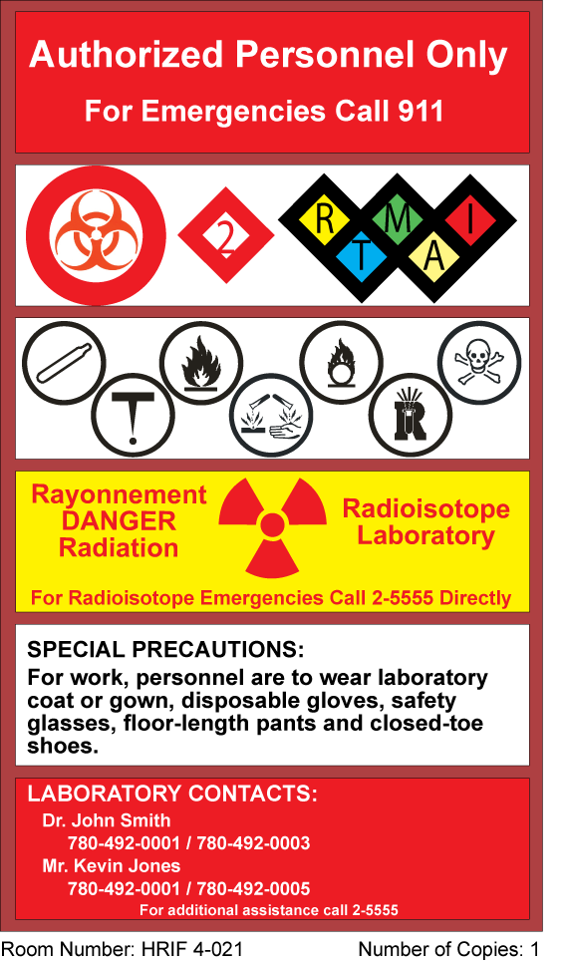
2
3
4
5
6
1. Access Restrictions and Emergency Response Instructions –Laboratories at the U of A are restricted to authorized personnel for the protection of anyone entering the space as well as for the protection of the work going on within the area. Individuals not authorized to enter the designated area but who require access shall do so under the escort of an authorized person.
In the case of an emergency (fire or medical) personnel are to call 911 for assistance.
2. Biohazards – Any laboratory working with biohazards is required to register with EHS (consult the EHS webpage for information on how to register). Signage indicates the universal biohazard symbol, the biohazard containment level and indicates the potential pathogen routes of entry/types of hazards (R = respiratory; M = mucous membranes; I = ingestion; T = toxin; A = allergen).
For specific information regarding a pathogen or toxin consult the product information sheet provided by the supplier or the pathogen-specific datasheets available on-line at the Public Health Agency of Canada. The ATCC (American Type Culture Collection) and the American Biological Safety Association websites can also provide additional pathogen information and risk group classification if needed.
3. Chemical Hazards Canadian Workplace Hazardous Materials Information System (WHMIS) symbols provide general information regarding the type of chemical.
Compressed Gas – gaseous material that is packaged under pressure in a cylinder or other container.
Flammable and Combustible Materials – solids, liquids or gases that are capable of igniting and continuing to burn if exposed to a spark or open flame.
Oxidizing Materials – chemicals that release oxygen and therefore increase the risk of fire if they come into contact with flammable or combustible material.
Poisonous or Infections Materials Causing Immediate or Serious Toxic Effects – acutely toxic materials that can cause immediate, serious health problems from a single, low dose exposure.
Poisonous or Infectious Materials Causing Other Toxic Effects – agents that can cause serious health problems from long-term exposure.
Corrosive Materials – caustic or acidic materials that can attack and destroy metals or cause injury to skin, tissues or organs.
Dangerously Reactive Materials – materials that may react violently in some circumstances and/or emit toxic fumes if exposed to water.
Consult the Material Safety Data Sheet (MSDS) for specific chemical information.
4. Radiation Hazards – Laboratories working with any radioactive substances must have a valid permit and all radiation-emitting or laser generating equipment must be registered prior to the installation of the hazard sign. Consult the EHS website for information how to apply for a permit or register equipment. Signage will reflect the type of radiation being used or stored in the laboratory and state that the U of A Control Centre is to be called, 780-492-5555 in an emergency to ensure the coordination of appropriate resources to deal with the emergency in a safe manner.
5. Special Precautions – All personnel working with hazardous material are required to wear personal protective equipment (PPE) and take appropriate precautions. In laboratory research settings, the U of A launched a PPE Initiative. Select the PPE that is appropriate for your work area. This should match the PPE that is listed on the PPE checklist. Any other special considerations or hazards in your area can be mentioned here as well, and the appropriate message will be placed on the sign.
6. Laboratory Contacts – Primary and secondary contact names with both office and after hour phone numbers are required. Laboratory contacts are personnel who are familiar with the type of work being done and the hazards present within the laboratory space and able to provide clear information regarding the hazards within the laboratory in an emergency. Given the transient nature of staff and students in academic research, the personnel taking on this role should be long term staff wherever possible. The laboratory contacts are NOT expected to personally deal with a life-threatening emergency situation.

