GL Importer tool
User Manual

Table of Contents

PURPOSE 2
INITIAL SET UP 2
PS Access 2
Preparing User’s Computer 2
CREATE JOURNAL 3
1. Create a New Journal Sheet (Journal Entry) 3
2. Create the Journal Header 5
3. Create the Journal Lines 7
IMPORTING JOURNAL 8
Journal errors and corrections 9
APPENDIX A: MACRO SECURITY SETTINGS 11
APPENDIX B: JOURNAL SOURCE 12
APPENDIX C: TROUBLE SHOOTING JOURNAL IMPORT ERRORS 14

PURPOSE
The purpose of this manual is to provide instructions on how to use the PeopleSoft (PS) GL Importer tool. This tool is used primarily for processing internal sales.

INITIAL SET UP

PS Access
The following roles need to be requested in order to use this tool:

ZGL_JRNL_XLS_ENTRY Allows the user to import journals to PS.
ZGL_JRNL_UPDATE Allows the user to edit journals that are in error status after import.

These roles require both SFO and Financial Services approval before they are granted.

Preparing User’s Computer
- PS access is granted to user

- Save mandatory files to user’s computer (Recommended location: C:\Users\ccid):
  - Navigate to https://www.ualberta.ca/financial-services/forms-cabinet
  - Scroll down to GLJE Requests/GL Importer Tool
  - Save JRNL1.xlsm and JRNLMCRO.xlam to user’s computer

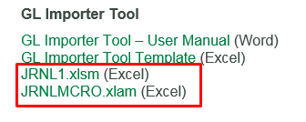

Note: Both files must be downloaded and saved in the same location. The files will import to PS from the directory where the files are saved. JRNL1.xlsm is the journal workbook used to create and import journals to PS. JRNLMCRO.xlam is the add-on required for importing journals. It is important to note that only one copy of the macro file should be saved on a user’s computer; if users save more than one copy, this will cause a compile error.

To save the JRNLMCRO.xlam file in the correct location after it has been downloaded, navigate to the Downloads folder. Cut and paste the file into the correct location. Note that the user does not need to open the JRNLMCRO.xlam file to use the tool.

- Ensure user’s Excel is correctly configured to allow macros. Refer to Appendix A.

Note that the GL Importer tool will not work with Mac computers.

CREATE JOURNAL
There are three stages in creating a new journal: creating a journal sheet, creating a journal header, and creating journal lines. These stages must be completed in the order presented.

Create a New Journal Sheet (Journal Entry)
The journal sheet is the spreadsheet which contains the journal header and the journal lines.
- Open the JRNL1.xlsm file

- To create a new journal sheet, click on the “New” icon on the main page.
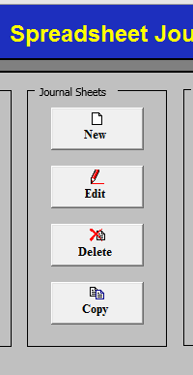

Note: if clicking on the “New” icon does not produce results, refer to Appendix A.

- Enter a name for journal sheet, click OK
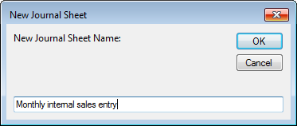

Note: the journal sheet name is for the user’s reference only and will not be shown in PS. It is used to track journal entries; it is not the journal ID. It is similar to naming an excel workbook. The name of the journal sheet cannot be edited once it has been created. Journal sheets can be deleted once users have successfully uploaded journals, or users can retain the journal to use as template (copy) for future journals. Units will determine their own naming conventions for journal sheets.

Existing journals can be accessed by selecting the “Edit” icon.

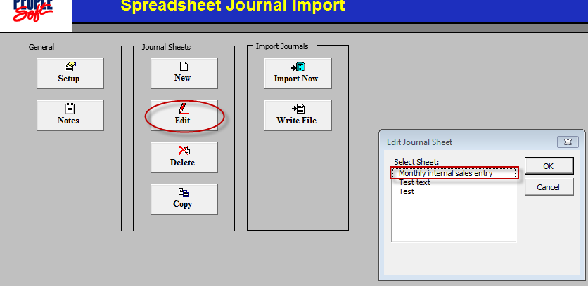

- The Spreadsheet Journal Import screen will open (users will not be able to see the journal sheet name in this view)
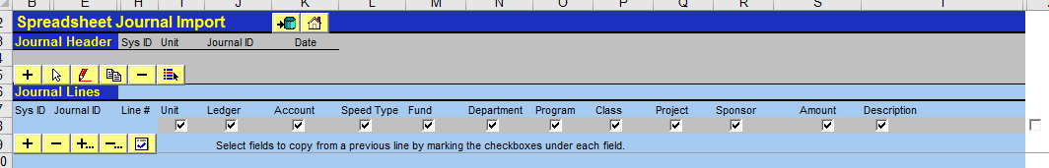

Note: the importing tool allows for copy and paste from the GL Importer Tool Template, which is located in the FS Forms Cabinet in the GLJE Requests section:
https://www.ualberta.ca/financial-services/forms-cabinet

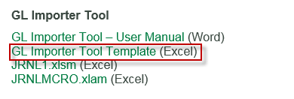

The fields on this template have been structured to reflect the PS processing requirements. Do not make any changes to the fields in the tool (e.g. change order, delete, or add).

Create the Journal Header
The journal header contains information that uniquely identifies the journal (i.e. journal ID, date).

- To create a new journal header select and the New Journal Header will open.
Note: this is the only button users will need to use in creating the journal header.

- Fill out the required fields as follows, using the information provided in the GL Importer Tool Template (only fill the fields that are required, leave the remaining fields blank):
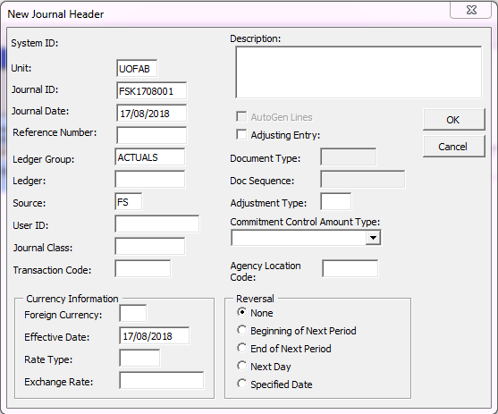
- Unit (Business Unit):
must be UOFAB
- Journal ID:
*See box below for numbering
convention*
- Journal Date:
post date of entry
NOTE that the date format is
dependent on the user’s
individual computer date settings

- Ledger Group:
leave as ACTUALS
- Journal Source:
use processing unit source code.
This should be provided by the
approver of the entry;
refer to Appendix B for list

- Select OK.

Journal ID
With the GL Importer Tool, all internal sales journal IDs are created by the user (i.e. not system generated). Journal IDs are 10 characters and must use the following Journal ID numbering convention:

First 4 characters (mask) = SALE
Next 3 characters = unit identifier (assigned by FS) (e.g. AFD; this is the “old” mask)
Last 3 digits = next number starting with 001*

Example:
Internal sale processed by Agricultural, Life and Environmental Sciences:

Journal ID will be: SALEAFD001

*Note: there are three options for the last three digits:
Option 1: start at 001, select next number for each journal and restart at 001 every month
The fiscal year central filing would need to take into account the date.

Option 2: start at 001, select next number for each journal and restart at 001 every year
The fiscal year central filing would be numeric, as no faculty processes 999 internal sales journals in a year.

Option 3: start at 001, select next number for each journal and restart once 999 is reached
The fiscal year central filing would be numeric, as no faculty processes 999 internal sales journals in a year.

Most faculties will process only once or a few times per month. FS recommends users start at “001” each month, which makes tracking the next number to use much easier. Units who process multiple entries every month will need to track last journal ID number used. FS uses this journal ID numbering convention for the GLJE Request FSK journals.

Identical journal IDs may exist in PS provided they have different dates.

Please note, the university currently does not have PeopleSoft module functionality for internal sales transactions. Because of this gap, the only option is to allow users to process directly to the general ledger (GL) through an import tool when processing a GLJE directly into PS General Ledger. Because of this, the user is required to assign the journal ID. In this process, PS cannot automatically assign any portion of the journal ID.

3rd party interfaces

Currently, there are four internal sales unit identifiers for which the journal IDs are system generated (user does not assign): MEC, TMS, PVI and UTL. Because they are system generated, there is a restriction on the number of characters used at the beginning of the journal ID (6). As a result, the journal IDs for these four unit identifiers will begin with SAL.
Example: SALTMS001

3. Create the Journal Lines
The journal lines contains the transactions making up the journal: the debit and credit entries.

Note: these buttons are used to add, delete, add multiple, and delete multiple journal lines.

- Add as many lines as required to copy and paste journal lines from the GL Importer Tool Template.

- Copy and paste data from GL Importer Tool Template or key data directly into the Spreadsheet Journal Import screen. Fill in either chartfield string or speedcode (called Speed Type in the GL Importer Tool). Note that if speedcode begins with zero, and apostrophe (‘) will need to be added to the beginning of the speedcode in order to retain the zero at the beginning of the speedcode (e.g. ‘01234). Account is required.
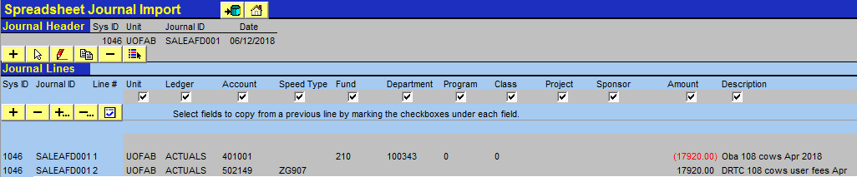

Note: If a user keys directly into the screen, data entered into a line will copy into subsequent added lines when:
  - The field checkboxes are checked off (users can check or uncheck these fields (based on preference) at any time during the journal keying process); and
  - A new line (+) or lines (+…) are added after data has been inputted in the previous line.

Unchecked boxes will not be copied when a new line is added

- Delete excess lines which do not contain data.
Note: excess lines which do not contain data will NOT import. Users may wish to retain them as a template for future entries.
- Once the journal is complete, a verification button is available to check if any values in the Amount column are in excess of 2 decimals. Click this button prior to importing the journal. A pop up error message will appear if there is an amount with more than 2 decimals.

- If there are no pop up error messages, import the journal.

IMPORTING JOURNAL

- When the file is ready to import, select the import button (above the Journal Header)

- The user will be prompted to enter their CCID and CCID Password (Uppercase CCID *Case Sensitive*) e.g. JSMITH

- The following message will appear at left hand bottom of the screen:
- Once the file has been imported, a message will indicate the journal status along with the journal ID.

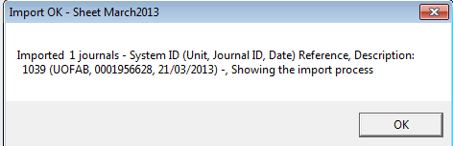

- Save and close JRNL1.xlsm.

Note: Running the journal import will result in three possible outcomes:
  - Import Failed – correction required
  - Import OK; in validate (V) status in PS but subsequently changes to error (E) the following hour – correction required
  - Import OK; in validate (V) status in PS and subsequently posts (P) the following hour

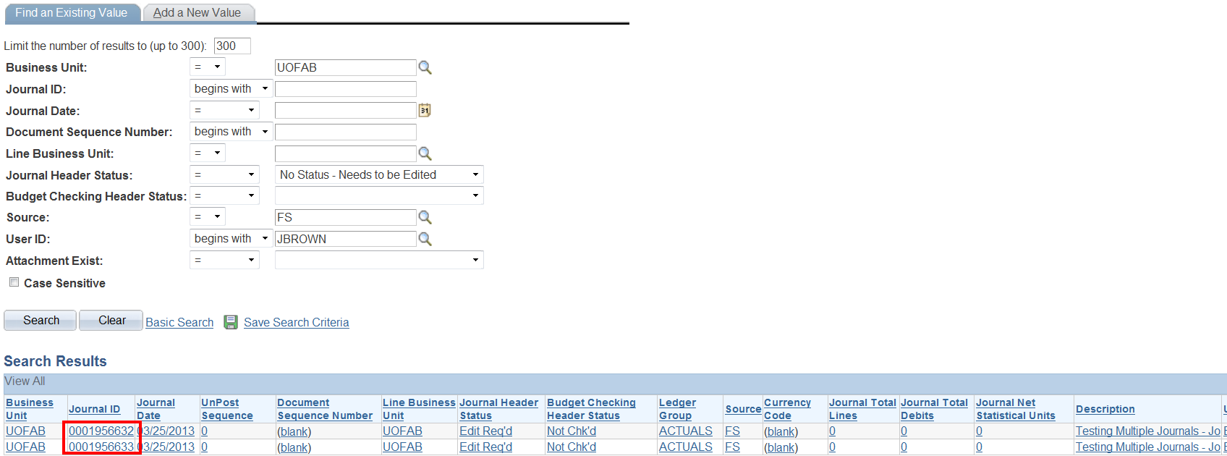

In PS, the online view will list the journal(s) that have been imported. Journals will be posted (if no errors) every hour.

Query output will appear as follows:

Journal errors and corrections
i. - Import Failed
If an ‘Import Failed’ message is received, the issue will be noted on the import pop-up. Journals that fail to import can simply be corrected in the template. Users do not need to start over, or exit the journal, or create a new journal sheet. Simply address the issue identified in the Import Failed message.
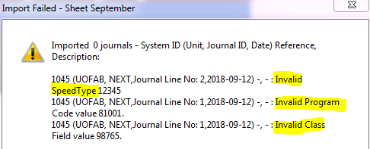

Refer to Appendix C for examples of common errors that will cause the journal import to fail (an ‘Import Failed’ message will pop-up and in most instances identify what the error is).

ii. – Import OK; in validate (V) status in PS but subsequently changes to error (E) the following hour
Once the journal import is successfully run the journal still needs to be reviewed to ensure it passes the PS budget and edit check validation process. To review the status of the journal, access the following path in PS: General Ledger/Journals/Journal Entry/Create/Update Journal Entries. To see any journals in error select ‘Journal has Errors’ choice in the Journal Header Status option. Correct the specified journal by clicking on it.

The following errors could exist and the journal will still import to PS (but the journal will not post to the GL after the validation process):
- Journal is not balanced
- Incorrect accounting period selected
- Chartfield combo edit error (e.g. project chartfield is missing in the restricted research fund)
Analysis type error
Users may encounter the following error message in PS after a successful import:
Analysis Type is blank or invalid combination with PC Business Unit, Project ID and Activity ID
An hourly program runs in PS which will correct the above error; users do not need to do anything. Wait one hour and check again to ensure the status has changed to posted.

Note: Third party interface journals will also need to be reviewed for journals in error (E) status even though they have not been imported into PeopleSoft using the GL Importer tool.

If the journal has errors that cannot be corrected before the month end deadline, users must delete the lines in error and allow the rest of the journal to process.

Uncorrected journals are deleted by Financial Services at 11:00am the first business day of the subsequent month.

APPENDIX A: MACRO SECURITY SETTINGS
Macro settings must be configured as follows in order for this tool to work.

Excel 2007/10/16

Open Excel -> File -> Options -> Trust Center -> Trust Center Settings -> Macro Settings:
Select disable all macros with notification
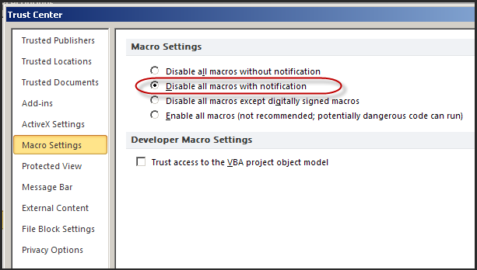

When you launch JRNL1.xlsm for the first time, select
“Enable Content” if the following warning pops up:

For Excel 97/2003
Open Excel -> Tools -> Macro -> Security -> Security Level tab:
Select Medium
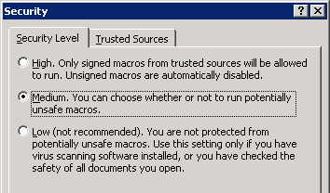

When you launch JRNL1.xlsm for the first time, select “Enable Macros” if the following pops up:
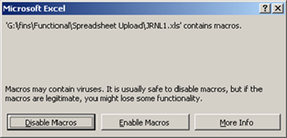

APPENDIX B: JOURNAL SOURCE

The following Sources are to be used when completing the Journal Header for internal sales.

 | Source | Faculty
Faculties
 | ALE | Agricultural, Life and Environmental Sciences
 | ART | Arts
 | AUG | Augustana
 | BUS | Business
 | EDU | Education
 | ENG | Engineering
 | EXT | Extension
 | KSR | Kinesiology, Sport and Recreation
 | MED | Medicine and Dentistry
 | NUR | Nursing
 | PPS | Pharmacy and Pharmaceutical Sciences
 | REM | Rehabilitation Medicine
 | SCI | Science
Central Service Units
 | ANC | Ancillary Services
 | BKS | Bookstore
 | DVO | Office of Advancement
 | FS | Financial Services
 | HRS | Human Resource Services
 | HSC | Health Sciences Council
 | IST | Information Services and Technology
 | LSV | Learning Services
 | OPR | Operations and Physical Plant
 | PRS | President, Secretariat, VPs
 | RMS | Risk Management Services
 | RSO | Research Services Office
 | SMS | Supply Management Services
 | STS | Student Services

The default source in the journal header is currently set to FS. To change this default, navigate to the home screen and select “Setup”.
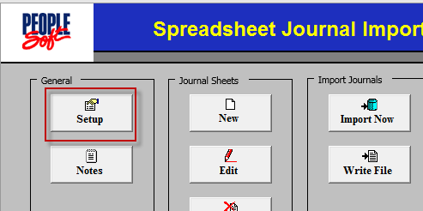
The following screen will appear. Change the Source and select “OK”. Do not change any other fields.
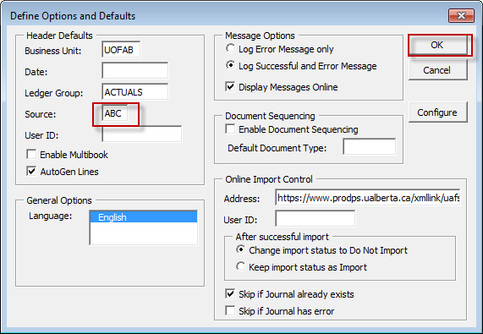

APPENDIX C: TROUBLE SHOOTING JOURNAL IMPORT ERRORS
Journal imports may fail (“Import Failed”) for the following reasons:
Error Message | Cause of Problem | Resolution
Invalid Chartfields (includes Account, Fund, Deptid, Program, Class and Project) | Chartfields do not exist or  are inactive in PS | Correct the coding right in the opened spreadsheet and import the file again
Invalid Unit or Invalid Ledger | Unit must be UOFAB  Ledger must be ACTUALS | Correct the coding right in the opened spreadsheet and import the file again  Correct Ledger Group in the journal header section (select edit button)
Invalid User ID or  password | User ID and/or  password entered incorrectly | Enter user ID in UPPERCASE  Enter password in regular case Check to see if CAPS lock is on
The server name or address could not be resolved | Import address is  Incorrect (address to PS)  No internet  connection | Contact the IST Helpdesk
An error occurred in the secure channel support | PS application service is down | Wait an hour and reimport again or contact LAN administrator
Cannot update journal with a status of Posted | A journal with a unique combination of journal ID and journal date has already been imported and posted in the system. | Determine if this is a journal that has already been imported.  Either change the journal date or change the journal ID in the journal header section (select edit button)
Imported 0 journals | Missing the  appropriate permissions in user’s PS profile to import journal | Contact the IST Helpdesk
Imported 0 journals:  Account/Alt Account  Field Required | Trying to import a journal  with no journal lines | Add journal lines  Check if multiple headers have been created and if the ‘sys id’ for the journal lines don’t line up with the journal header

For any journal import error not listed above, please log a helpdesk ticket.

The journal log contains information for every imported journal (successful or failed). The file (JrnlLog.xls) will automatically save in the same location as the JRNL1.xlsm file. Users do not need to review this journal log information; however, if the user has an error which requires an IST ticket, this log message can be used.

A journal import may be successful (“Import OK”) but not post a journal to PS in the following situation:

Error Message | Cause of Problem | Resolution
Imported 0 journals  (no further details in the pop-up) | A journal with a unique combination of journal ID and journal date has already been imported but has not yet posted to the GL (validation stage). | Determine if this is a journal that has already been imported.  Either change the journal date or change the journal ID in the journal header section (select edit button)

